**Boiler Analysis 12&13**

Intern-Aryan Verma

Mentor- Mr.Shoubhik Singha

Senior Support- Mr.Anil Verma

Department- CPP Technical

**Aim**

To reduce the amount of unburnt carbon . Perform analysis on Boiler 12 and 13 with the records of most recent business year(2023-2024).

**Introduction**

To produce electricity, steam is generated in the boilers to rotate the turbines of an electric generator.

The fuel(coal) should be burnt completely for best efficiency , if some coal is left unburnt , we call it Unburnt carbon(can be bottom ash, ESP , etc).

Performed EDA(Exploratory Data Analytics) for year 2023-2024 record to find out which factor should be used in which quantity.

**Note**

All Data Analyst Projects are made by keeping in mind that the creator will have to explain it himself. The visuals and results might not be appealing to eye because Dashboards and APIs used for presentation is handled by different domain.

**Theory**

Factors we need to take care of(Provided by mentor) :-

Coal Quality- FC, VM, Moisture, Ash, GCV

Flue Gas Analysis- Avg O2 at APH inlet, Leakage across APH, Avg O2 at APH Outlet, Air I/L temp FD outlet, Flue gas temp outlet

Unburnt Analysis(Target)- Bottom ash Carbon, ESP Ash Carbon, Cyclone Ash Carbon, APH

Ash Carbon

Air Analysis- Theoretical Air, Excess Air, Actual Air Supplied, Mass of Dry Flue Gas

Unburn Loss- ESP Ash , Bottom Ash, Cyclone Ash, APH Ash

Sensible Heat Loss- Only used “Total Loss” to reduce the amount of variables for analysis with respect to the data quantity.

Boiler Efficiency- Calculated by computer, not a dependent variable

**Procedure for Boiler 12&13**

**1.Preparing the Data file**

1. Created a separate csv file to store data.
2. Broke all Excel file links(didn’t mention about links while providing data).
3. Used copy , paste special, and transpose, for all months data.
4. Indexing and verifying records periodically.

2.Processing

1. Creating dataframe.

2. Replacing null(or 0) with mean(won’t reflect changes in actual datasheet).

3. Using “info()” function to understand for the data types and basic info.

4. Created 2 separate DataFrames(top 30, worst 30) depending on Unburnt ash carbon.

3. Visual Analysis(coal and air)

* Made histograms for coal quality in top 30 and worst 30 dataframes.
* 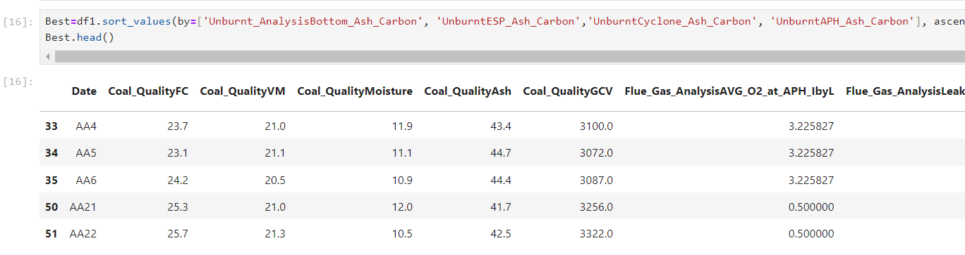
* Compared distribution of frequencies in best and worst cases for GCV, FC, VM, Moisture and Ash.

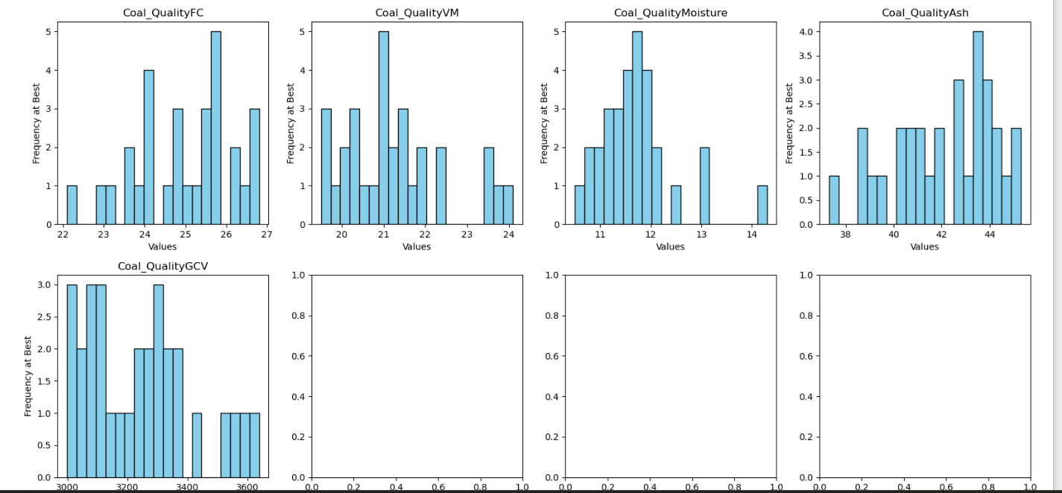

* Primary Target- “Unburnt Bottom Ash Carbon” , plotted a covariance graph to understand majority influence is of "Excess Air".
* 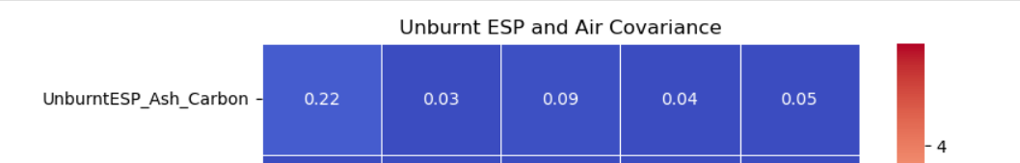
* Excess Air( Theoretical Air- Actual Air supplied) is passed on purpose for complete combustion of carbon , need to know by how much percentage.
* Secondary Targets: ESP and APH ash carbon. APH is not affected, but ESP is affected by Excess air as well.

4.Pattern Recognition

* Drew Pattern for unburnt carbon with excess air.
* Created a function to plot selected data for every month.
* Drew plots for (Unburnt bottom ash carbon, Excess air), not fruitful.
* Drew plots for (Unburnt bottom ash carbon, Flue gas O2 at outlet), turns out O2 deviates very less.
* Drew plots for (Unburnt bottom ash carbon, Excess air, Hydrogen), pattern became confusing.
* Box Plots to measure central tendencies, detect a limit to find outliers. Clear confusion with Hydrogen(because it was constant).
* Found limits to detect outliers in our plot.
* Normalized GCV to fit in the same range as the plot. Drew plots for (Unburnt bottom ash carbon, Excess air, Hydrogen, GCV(normalized)). Plots are more meaningful.
* 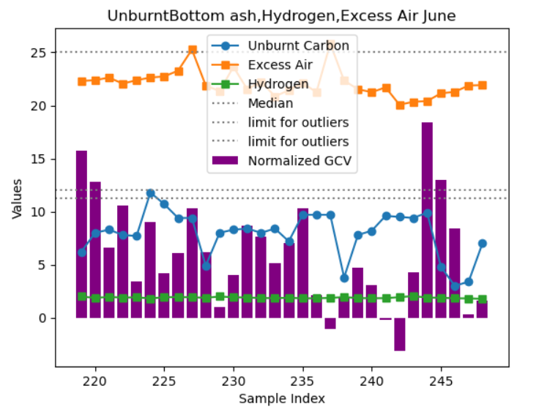
* Plotting same for “Top 30” (data rows not in serial order).
* 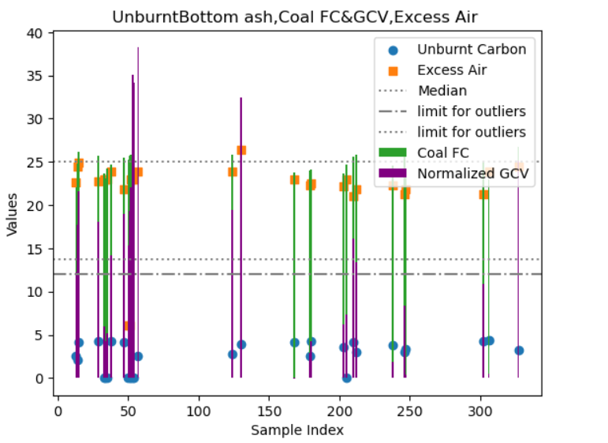
* Final comparison on Top 30 and worst 30 for different factors.

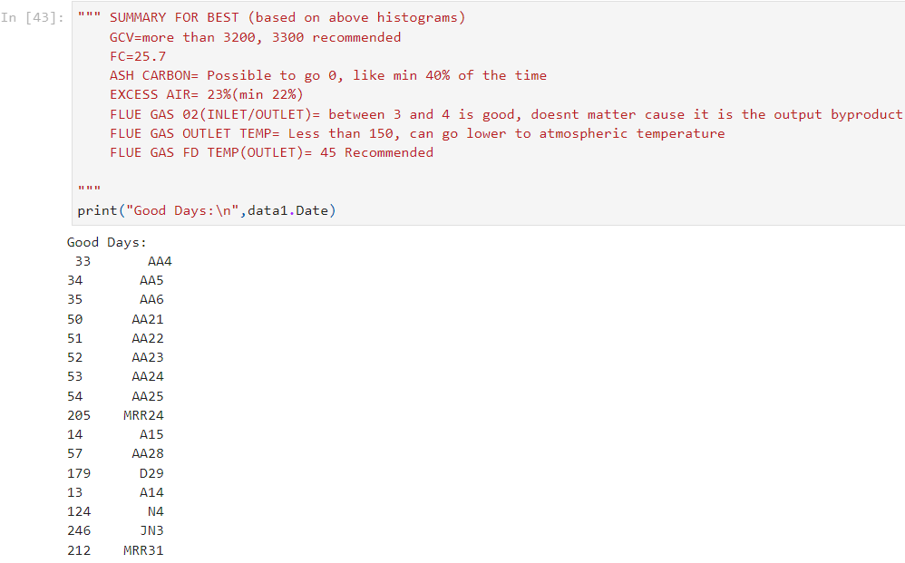

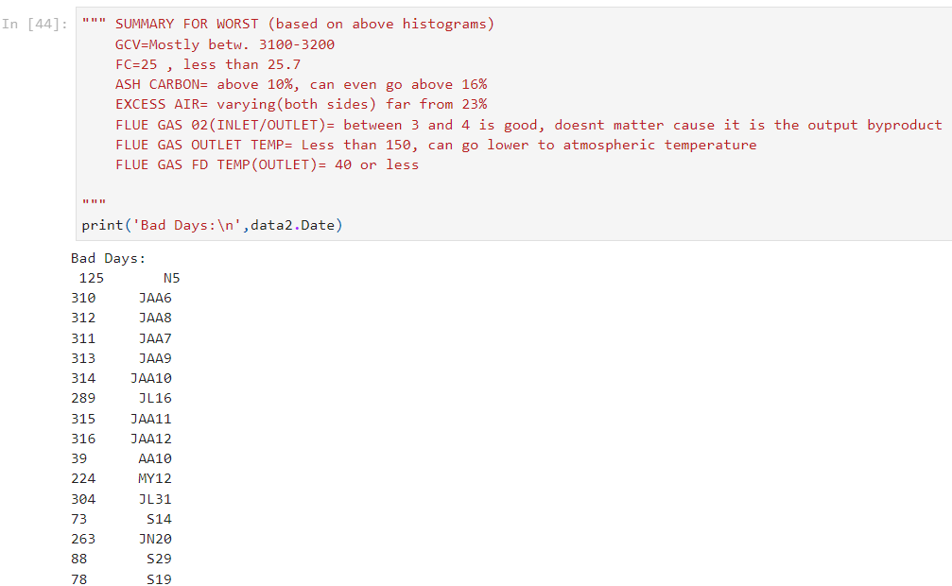

1. Applied the same for boiler 13 and compared the observation. Same results fetched.

Result

Following insights have been found:-

SUMMARY FOR BEST (based on above histograms)

GCV=more than 3200, 3300 recommended

FC=25.7

ASH CARBON= Possible to go 0, like min 40% of the time

EXCESS AIR= 23%(min 22%)

FLUE GAS 02(INLET/OUTLET)= between 3 and 4 is good, doesnt matter cause it is the output byproduct

FLUE GAS OUTLET TEMP= Less than 150, can go to 0, 0 recommended

FLUE GAS FD TEMP(OUTLET)= 45 Recommended

SUMMARY FOR WORST (based on above histograms)

GCV=Mostly betw. 3100-3200

FC=25 , less than 25.7

ASH CARBON= above 10%, can even go above 16%

EXCESS AIR= varying(both sides) far from 23%

FLUE GAS 02(INLET/OUTLET)= between 3 and 4 is good, doesnt matter cause it is the output byproduct

FLUE GAS OUTLET TEMP= Less than 150, can go to 0, 0 recommended

FLUE GAS FD TEMP(OUTLET)= 40 or less

Summary

If followed the above metrics,

Unburnt Carbon can go upto: 0%.

Contributions:

Mr.Shoubhik Singha for their exceptional statistical advices and monitoring the insights with actual boiler mechanics.

Mr. Anil Verma for providing the overall theoretical knowledge, technical facility, networking, also providing an opportunity to upgrade their library.